Design Decision Document
ECET 230-002
Joshua Arriola & Maynor Roldan-Marin
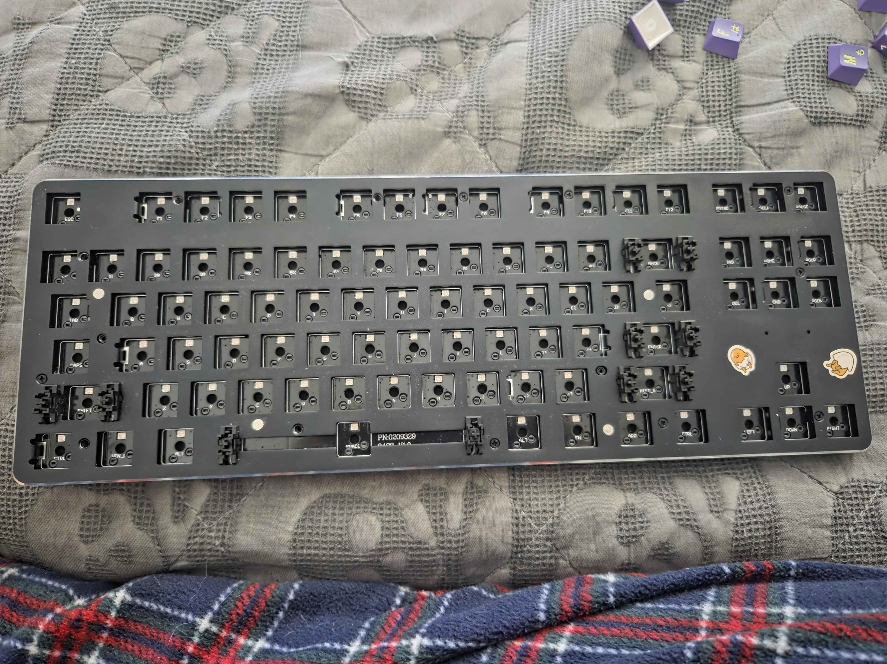
When our professor first announced the project, we had to pair up and pitch two product ideas for this class. One idea was a battery pack, and the other idea was a custom keyboard. We went with a custom keyboard idea, so we needed to learn how to design a keyboard from scratch, since we were still learning how to develop and what materials were needed. The first thing we needed to do was identify the components that make up a keyboard. So one of us actually reverse-engineered a keyboard model that the other had lying around. The keyboard model was a glorious tenkeyless model, which looks like this.

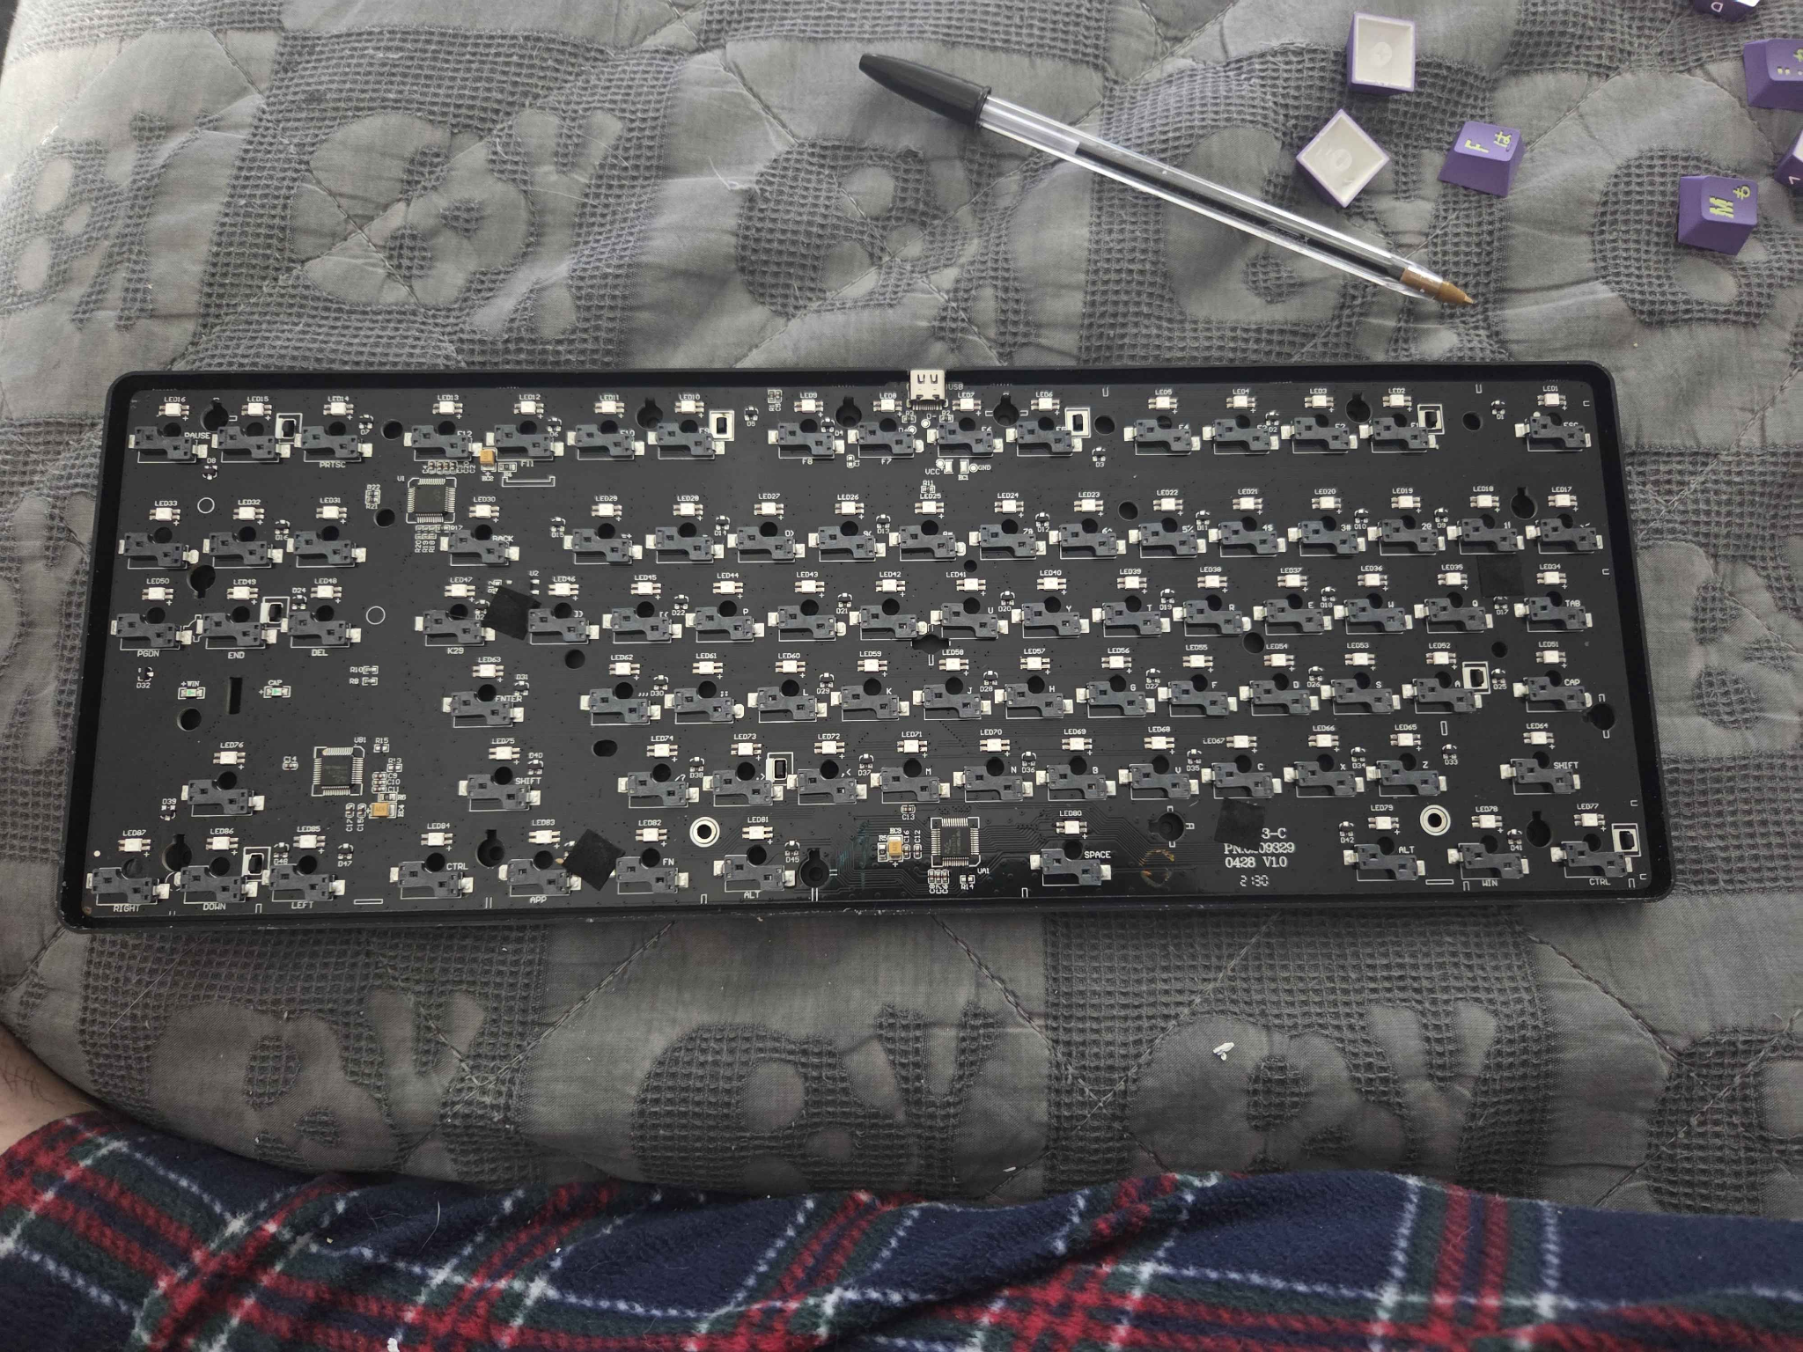

Once we took apart the circuit board, we noticed that this keyboard is comprised of 88 key switch sockets, 88 LEDS, 88 diodes, 3 microcontrollers, a couple of capacitors for each microcontroller, a couple of resistors, 3 encoders, and 3 SMT microcontrollers (basically a 32-bit controller, but this model has 3). After reviewing which parts this keyboard used, we wanted to implement something similar to this model's design but make it different, since the point of the project is to create a custom PCB.
So in our model, we decided to skip out on the LEDS and Bluetooth connection since that would take more time to understand schematic wise, we opted for a wired connection instead for fast inputs and a strong connection. We also decided to go with a 61-key switch version instead of an 88-key version to save time and money, since manufacturing a keyboard can take a lot of time and money. The first thing we needed to do was create a proof of concept, so we made a two-switch keyboard out of a small cardboard box to see if it was possible using an Arduino Pro Micro board and soldering some wires. Surprisingly, it worked, so we proceeded to the next phase, which was deciding what it would look like.
So we need a shell first, which holds the circuit in place, protects it from debris, and allows the circuit board to be held in place. We went with an Adafruit keyboard shell model GH60, a 60 percent keyboard that fits up to 61 keys, which was what we were looking for since we wanted to build a small, simple keyboard. While we waited for the keyboard case to arrive after ordering, we began deciding how to construct this circuit board. A keyboard matrix was needed to define the wires and connections to the microcontroller we were using, so we needed 5 rows and 14 columns of wires in KiCad. A keyboard matrix is a grid of wires organized in rows and columns.
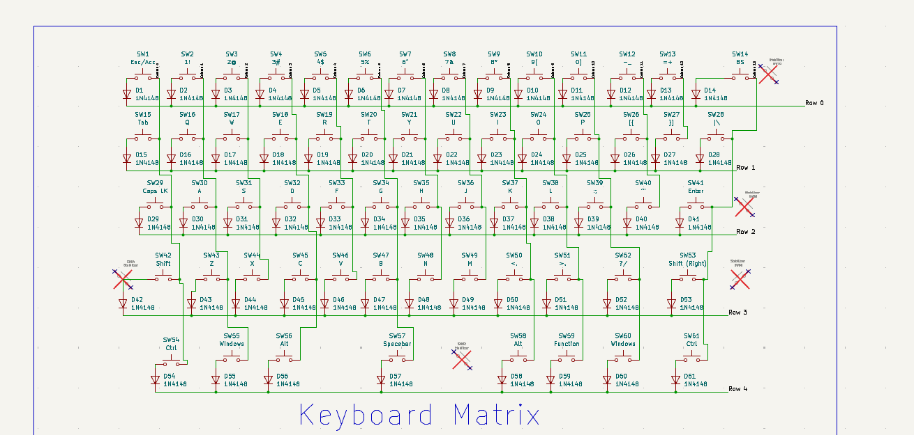

Then we needed to establish which rows are 0-4 (technically, rows 1 to 5) and which columns are 0-13 (technically, columns 1 to 14). Then we needed to pick a microcontroller. For context, we were told not to use a Raspberry Pi, so after asking around in the Discord community and work acquaintances, we were told that an Atmega32U4 would be used since it would be attached directly to the circuit board ourselves. The Atmega needed power from 2.7 to 5.5 volts to power on. What we tried to do was attach a voltage regulator to make sure it cuts power down to at least 3.3 volts or somewhere around that.
We also had to make sure the connection supported USB-C, since USB-C is very common nowadays, and the keyboard needed to be hot-swappable (changing components while the device is on or off) to replace keyswitches and keycaps. We also needed to ensure the sockets could accommodate 5 pins instead of 3. The reason is that many keyswitch models have 5-pin legs (3 are plastic and 2 are metal). One of us mentioned that we should have the sockets accommodate 5 pins, because if our circuit board only allowed 3 pins, you would need pliers to remove two legs of the keyswitch to make it fit inside the circuit board. So we had to use a keyswitch model that would allow 5 pins; it will still work if the switch is 3 pins too. The sockets also needed to match the switches' orientation because, when we were assembling them on the schematic, we noticed the sockets were not facing the correct positions. For example, a normal switch has one pin on the bottom left and one on the upper right; the footprint we used in KiCad showed the opposite.
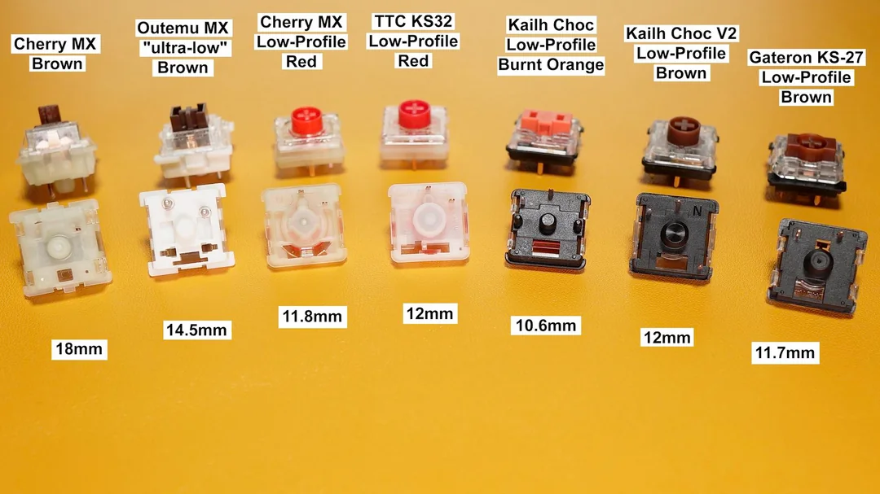

We wanted to ensure that the circuit uses only Cherry MX Brown switches (cherry mx brown photo). Going back to the USB-C connection, since it is type C, we needed to implement resistors for pull-downs and add data plus and minus wires to the USB-C model to get it to work with the microcontroller. The microcontroller needed many components to come to life. We needed a crystal oscillator that divided the power between the two capacitors it’s attached to to ensure a stable connection. It needed a reset switch to install firmware, new or old, and a capacitor for Ucap (external connection pin to allow the microcontroller to run at 5 volts). Pins needed to connect to the corresponding rows and columns (PB0-PB3 and PB6 are the rows and columns identified as PB4-PB5, PD0-7, PF0-PF5). There was a voltage regulator that was supposed to be attached to the microcontroller, but we made a mistake and forgot to connect it; it still works regardless (we will update that later).
The next part, which is still a work in progress, was coding, similar to what we did for our POC, we needed to establish rows and columns. Since we now have more rows and columns to work with, we need the X-axis to show only 5 rows (0-5) and the Y-axis to show only 14 columns (0-13). A key point is that one is recognized as zero, so each code needs to start at zero. First, we needed to create a JSON file by using QMK MSYS. This program allows us to create a keyboard layout from scratch. We needed to type the command “QMK compile,” then tell the program it is a pro micro chip and a new custom layout. Once it recognizes that we need a layout, it will provide us with a default layout to which we can change to match our keyboard matrix that we created in KiCad. The main reason we are using QMK is that it allows the software to configure and map keyboard codes to specific points on the circuit board. Once the JSON file knows that we need 5 rows and 14 columns, we need to map keycodes to specific points in the circuit to act as a proper keyboard (basically 0,1 = number key 1, and 0,2 = number key 2). This is very necessary for the microcontroller, since its main job is to scan the matrix for signals and display the output.

